

Unilever’s Approach to Digital Transformation

BCIS 5700 - Project 1
Team 2: Hrutuja Umesh Satpute, Ryan Malin, Harini, Gaurishankar, Dhiraj Dcosta, Gilbert Vijayan


Table of Contents

Company Overview 3
Project Overview 3
Business Problem 3
Scope: What process was involved? What regions? 4
Technology Vendor 4
Timeline 5
Cost 5
Technology Overview 5
Implementation Challenges 6
Benefits Achieved 7
Porter’s Five Forces Analysis 7
References 8

Company Overview
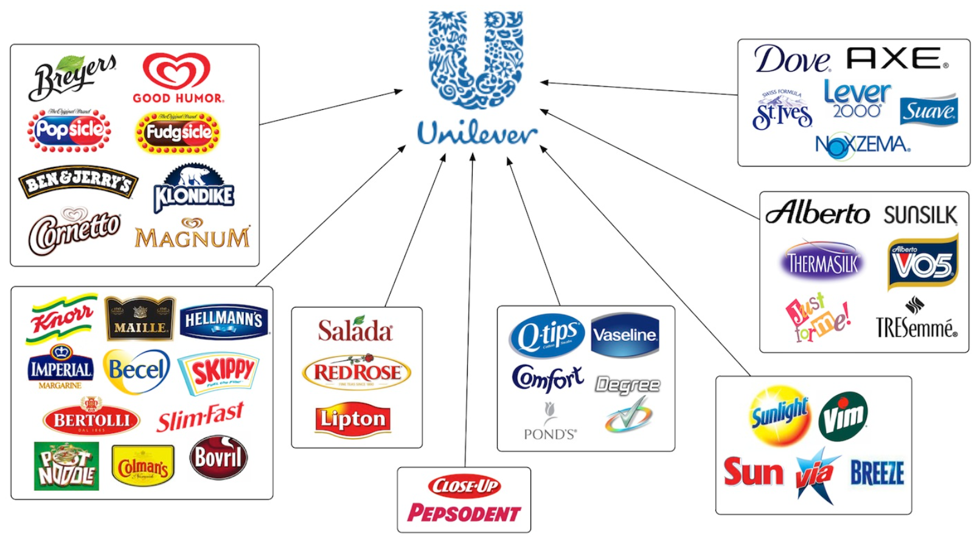
Unilever was founded in the year 1929 through a merger of the Lever Brothers and Margarine Unilever. With London, UK being the headquarters, Unilever is spread across 190 plus countries. The company has several divisions with popular brands as seen in the image above that has contributed to its annual revenue of $71.78 billion with 11.55 billion as group profit before tax for the financial year 2024.

Unilever wished to concentrate and focus on its four business units: Beauty & Wellbeing, Personal Care, Home Care and Nutrition. With a demerger of the ice cream division in December 2025, The Magnum Ice Cream Company (Magnum Company, n.d.) was formed as Unilever‘s subsidiary with its headquarters in Amsterdam.
According to Unilever's annual report of 2024, the company's turnover increased to €60.8 billion, having a 1.9% growth compared to in 2023. Unilever’s Underlying Sales Growth (USG) reported 4.2% increase in the group level at both the volume and price levels.
The Underlying operating profit rose by 12.6%, helping in margin expansion. Gross margin became better by 45% reflecting supply chain efficiency and price discipline. For the Ice cream division the margins remain different due to more energy requirement and refrigeration leading to separating the Ice cream business into a standalone one. The Magnum Ice Cream Company allows the company to focus better on improving the long term-margins.

Project Overview

Business Problem
Globally, Unilever is one of the largest ice cream manufacturing companies. It has established 35 factories with 3 million freezers in 60 countries (Unilever, 2024). With these numbers, it is necessary for the company to maintain the stock available to meet the increasing demand. Ice cream is an impulse buy usually dependent on weather, local events and seasonality. For example, during a hot season or a heat wave if a person stops at the ice cream station and finds that the ice cream is out of stock, then the retailor has lost a sale. The traditional methods used by retailers for restocking included manual checks and contacting distributors. This was highly inconsistent and delayed operations resulting in inventory mismatch. This in turn leads to lost revenue and poor customer experience. Overall, they had a problem of understanding when the freezers needed to be restocked depending on the demand.
Since, Ice cream is an impulse buy, if it is unavailable sale usually goes to the competitor. Unilever's biggest competitor Nestle/Froneri (Harvard edu, 2017) is also using digital cold chain technologies. There are also brands such as Cooler Screens which is a retail tech platform which converts the freezer doors into smart displays. Unilever's needs to keep on optimizing and improving their supply chain if they want to stay ahead of this curve.

Scope: What process was involved? What regions?
Unilever has 35 ice cream factories and around 3,000,000 ice cream freezer cabinets in 60 countries. 100,000 AI installations have been completed as of 2024 and 350,000 are the targeted installations in 2025 (Unilever, 2024).
The factory sources ingredients and material from its suppliers, produces ice cream and delivers it by refrigerated vans to distributors or direct dispatch (Tom Chapman, 2024) to retailers based on Freezer stock levels. The supply chain system relies on real time stock using AI for data insights that is generated based on the images captured by the camera installed in the refrigerators and the weather data.
Process:
- A camera is fitted inside the refrigerator that takes photos parodically.
- The photos are sent to the cloud, where they are analyzed by AI that is trained to identify only Unilever’s ice cream brands and their depth in the cabinet.
- An algorithm is used to generate an order for the distributor. The distributor exactly knows how much ice cream stock is needed when the store owner places an order.
- When the freezer compressor runs, a smart liquid lining freezes at –21 degrees Celsius. If there is a power outage, the lining uses the energy that the ice water gives off. (Lining is like an insulation in a cool bag). However, in countries where there are no frequent power outages, the freezer temperature is –12 to –18 degrees Celsius.
- Data that is processed provides insights all along the supply chain, and for marketing and sales purposes.
Deployed Regions:
South Africa, USA, Pakistan, UK, India, Middle East, Denmark, Turkey, Hungary, Indonesia, and Germany.

Technology Vendor
CoolIR Group

Timeline
Commenced on February 2022 – End date not provided.

Cost
No cost is provided; however, there are general components of the smart refrigerator.
- Refrigerators are owned by Unilever (Already existing setup)
- Recurring cost for use, Service cost per location. Internal cameras, Computer processor, IoT, AI powered analytics, Temperature sensor, Weight sensor, Development costs.

Technology Overview
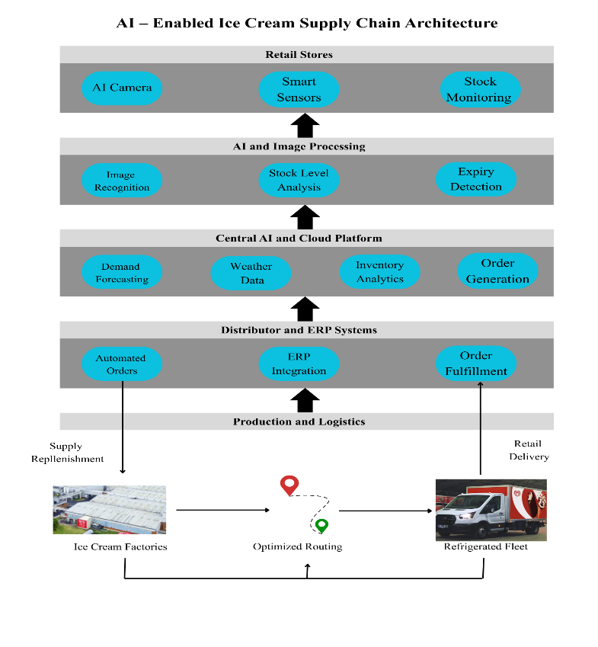
To address rising inventory concerns, Unilever launched a threefold pilot program which aimed to improve upon their existing logistics and operations. In the first example of this, Unilever leveraged AI to capture real time insights into their stock, allowing for more efficient restocking and maximized revenues for its customers. This technology was implemented into each of their 3 million freezers around the world, where a camera periodically captures images of the freezer’s stock, analyzes the image in the cloud, and automatically creates an order for distributors. This augmented inventory management has met with evident success: as described by Sarosh Hussain (Unilever, 2024), their head of digital systems, retailers across the world have seen at least 8% and as much as 30% growth in sales. In this way, Unilever’s use of AI has engendered significant improvements in its operations and in its financial performance.
This innovative pilot program also increases the functionality of their massive fleet of freezers, enabling store owners to maintain and receive real-time insights into their inventory. Software inside the freezer monitors stock levels periodically and alerts store owners when a product is out of stock, even suggesting a quantity for them to refill. These freezers not only relay inventory status but also use this data to analyze the success of offers to their consumers. The heightened inventory awareness brought about by this innovation allows Unilever and its customers to make smarter decisions and better optimize their stock to meet changing demands.
In addition to empowering its customers through enhanced operations, Unilever has established two other pilot projects which make use of sales data to make informed decisions regarding its value chain. In Turkey, one such project uses data to predict products which are likely to encourage an impulse purchase from a customer (Liz Dominguez, 2022). Unilever gathers data on its customers’ previous purchases and turns this data into actionable recommendations for its customers. Through a data-driven decision-making process, Unilever ensures that its marketing is tailored to each mobile user, offering a greater chance at an impulse purchase as a result.
Another facet of Unilever’s technology pilot emphasizes their focus on efficient and rapid delivery through their robust logistics system. Estefania Lupercio, the transformation head of their Latin American branch, fostered this change by gathering customer location data to derive the fastest possible delivery route. After a customer place an order through WhatsApp, the logistics team has it prepared and delivered via refrigerated delivery vans in under five hours. By optimizing their delivery system to best meet the needs of their customers, Unilever’s sales in this sector grew by over 25%.
The final example of Unilever’s transformation can be seen in their partnership with Robomart, a company which offers mobile and cardless shopping experience in the form of a van. These vans are then stocked with Unilever’s ice cream products which are delivered to their customers. This initiative was launched to address a changing consumer landscape where customers are more digitally oriented, preferring a hands-off ordering experience. Russel Lilly, general manager of Unilever’s North American ice cream front, describes it as a blend of “the joy of browsing the traditional ice cream truck and the technology of the 21st century” (Liz Dominguez, 2022). Through the introduction of these pilot programs, Unilever has increasingly employed digital technology to make their operations slimmer, faster, and more effective.

Implementation Challenges
1. Phased Deployment Across Millions of Freezers: Placing AI cameras on all 3 million freezers was neither economically nor operationally feasible so Unilever implemented a gradual implementation strategy in high-selling markets to achieve 100,000 by 2024 and 350,000 by 2025 (Unilever, 2024).
2. Integrating AI-Generated Insights with Distributor Ordering Systems: Unilever incorporated stock assistance produced through AI in the distributor ordering systems, and such markets as Hungary could integrate both traditional orders and AI-generated replenishment recommendations and, in particular, during peak seasons (Unilever, 2024).
3. Managing Extreme Weather Sensitivity in Demand Forecasting: Unilever implements AI weather forecasting and freezer tracking, which is a fast method of modifying stock and responding to demand surges due to temperature changes in real time (Unilever, 2025).
4. Aligning Distribution and Route Planning with Real-Time Replenishment: Digital tools to optimize routes were employed to streamline AI-based demand to the refrigerated logistics in Unilever to enhance effectiveness in delivering goods and their costs and energy consumption (Unilever, 2025).

Benefits Achieved
1. Increase in sales growth: With the use of 100,000 AI-enabled freezers, Unilever was able to bridge the gap between suppliers and retailers by following the agile process. Statistics show that, US, Turkey and Denmark saw a rapid increase in sales of 12%, 8% and 30% respectively, with the use of AI and forecasting (Unilever, 2024)
2. Cost optimization by reducing wastage: With digital transformation, Unilever was able to achieve better demand forecasting and production optimization, which resulted in a 10% reduction in wastage (Unilever, 2025). For a company like Unilever, which operates globally, a small reduction in raw materials can benefit the company by saving millions of dollars annually.
3. Real-Time Inventory updates: The smart camera benefits in providing real-time image snapshots of the inventory which helps the supplier to prepare beforehand and thus prevents going out of stock. Based on ice-cream sales, the AI enabled camera provides recommendations to the distributor to generate automatic orders. This resulted in a 5% increase in order (Unilever, 2025).
4. Customer Satisfaction: The digital transformation streamlined the process of automatic order processing from the AI enabled camera. Due to this, the freezers always have ice cream stocked, providing high availability and greater customer satisfaction.
5. Improved supply chain: Due to the AI driven insights, Unilever is able to optimize delivery rounds and production planning. Overall, leading to manual effort reduction, improved operational efficiency, lower cost, and time management.

Porter’s Five Forces Analysis
1. Threat Of New Entrants: The AI-powered freezer system and digital supply chain developed by Unilever create barriers to high technology and distribution, and it is hard to enter the company on a large scale.
2. Bargaining Power of Suppliers: AI-based demand forecasting enhances the procurement planning, making it less volatile and empowering Unilever in its bargaining position with suppliers.
3. Bargaining Power of Buyers: Despite the retailer’s bargaining power, there is an enhanced value of Unilever to retailers with the introduction of smart freezers and real-time inventory information.
4. Threat of Substitutes: Sales insights provided by AI can be used to optimize flavour mix and availability to mitigate the effect of substitute dessert products.
5. Industry Rivalry: Overall AI provides Unilever with a competitive advantage in a crowded market because end-to-end integration increases efficiency and responsiveness of its operations (Team GreyB, 2025).

References
coolR Group. (n.d.). Milestones. Retrieved https://www.coolrgroup.com/about/#:~:text=The%20next%20chapter%20after%207,Expanding%20team%20in%20UK%20hub
Harvard edu. (2017). The Digitization of Ice Cream. https://d3.harvard.edu/platform-rctom/submission/the-digitization-of-ice-cream/
Liz Dominguez. (2022, May 13). Forget Ice Cream Trucks and Say Hello to Robomarts, Unilever’s Newest Pilot. Retrieved from ConsumerGoods.com: https://consumergoods.com/forget-ice-cream-trucks-and-say-hello-robomarts- unilevers-newest-pilot
Liz Dominguez. (2022). Unilever Powers Up Ice Cream Restocking With Data-Driven App and Pilots. https://consumergoods.com/unilever-powers-ice-cream-restocking-data-driven-app-and-pilots
Magnum Company. (n.d.). Retrieved https://corporate.magnumicecream.com/en/home.html
Team GreyB. (2025, September 26). How Unilever is using AI for Supply Chain Optimization? - GreyB. GreyB. https://greyb.com/blog/unilever-ai-food-supply-chain/
Tom Chapman. (2024, August 29). Unilever: Boosting Efficiency in its End-to-End Supply Chain. https://supplychaindigital.com/logistics/unilever-boosting-supply-chain-efficiency
Unilever. (2024, August 22). How our AI-enabled freezers are revolutionising ice cream sales. https://www.unilever.com/news/news-search/2024/how-our-aienabled-freezers-are-revolutionising-ice-cream-sales/
Unilever. (2025, January 22). How AI is transforming Unilever Ice Cream’s end-to-end supply chain. https://www.unilever.com/news/news-search/2025/how-ai-is-transforming-unilever-ice-creams-end-to-end-supply-chain/

